Full paper
Importance requires
- The full paper should be 3,500 words, including an abstract of 250 words.
- The original article must be included in a separate section entitled "Title, Abstract, Introduction, Material and Methods, Results, Discussion, Conclusion, Acknowledgement, and Conflict of interest".
- The original article should not be over 40 references.
- The total of figures and tables is no more than 8
- Additional condition in the text;
- p-value >>> JHSMR’s formatting use “p-value” in all words
DO NOT USE
-“ P”
- “p”
-“P-value”
-“p-value”
-“p-value”
2. Standard Deviation (S.D.) >>> JHSMR’s formatting use “S.D.”
3. Abbreviations>>> JHSMR’s formatting has an abbreviation formatting as follows
- In the abstract
3.1 The words which mention just 1 time in your abstract do not use the abbreviation. You should use the full name, even if these words are well known, for example, in your abstract mentions to “WHO” just 1 time. You should use “World Health Organization” in that word.
3.2 The words which mention more than 1 time in your abstract, and you consider using the abbreviation. You should use the full name with the abbreviation in the parentheses in the first usage. After, this first usage, the abbreviation must be used consistently.
- In the introduction to the conclusion
Do the same as the abstract but re-start the words which ever used in the abstract.
- The percentage number >>> JHSMR’s formatting use 1 decimal in all percentage numbers, such as
- 50% >>> use 50.0%
- 41.22% >>> use 41.2%
- References style in the text >>> JHSMR’s formatting uses the Vancouver style. The references, which are cited in the text should be ordered from minimum to maximum. The numbers must appear in superscripts before the closing period and comma.
Title of full paper
First Name Surname, Degree^{1*}, First Name Surname, Degree¹, First Name Surname, Degree², First Name Surname, Degree ^{1,2}
¹Department, Faculty, University, City, State Zip code, Country.
²Department, Faculty, University, City, State Zip code, Country.

*Corresponding Author
Contact: First Name Surname
Affiliation: Department, Faculty, University, City, State Zip code, Country.
E-mail: AAAAA
(*corresponding author doesn’t fix in the first author, therefore it can move to another)

Abstract:
Objective: Many medical biosensors have been widely developed for use in clinical diagnosis as point-of-care testing. However, most of them still suffer from inaccurate results, caused by the lack of biosensor stability under variable pH of biofluid samples; such as urine. Hence, the instability in pH variation is one of the key challenges for electrochemical biosensors. In this study, the development of a gold nanoparticles-Prussian blue (AuNPs-PB) based screen-printed electrode was investigated for its performance, in terms of electrochemical stability within various pH solutions.
Material and Methods: The AuNPs-PB modified screen-printed gold electrode (SPAuE) was developed and optimized using an electrodeposition technique and cyclic voltammetry, respectively. As compared to PB modified SPAuE, the signal response of cyclic voltammograms at AuNPs-PB modified SPAuE was examined in a phosphate buffer solution with different pH values. The electrochemical stability of the modified SPAuE was considered on the invariability of the Prussian blue (PB) redox current in different pH solutions.
Results: The result revealed that stable current signals of PB in different pH solutions at the AuNPs-PB modified SPAuE showed good electrochemical stability, with a relative standard deviation (RSD) of oxidation and reduction peak currents being 1.03% and 1.11%, respectively. The signal stability results exhibited over two and five times when compared to those of the PB modified SPAuE (without gold nanoparticles), which were 2.41% and 5.61% RSD, respectively.
Conclusion: The AuNPs-PB modified SPAuE provides a potential, alternative tool for the enhancement of electrochemical stability for use in medical biosensor applications.
Keywords: (the keywords should be listed 3-6 keywords of the highlighting point of your paper, and ordered from a-z e.g.: isoflavonces, soy milk, Thailand)

Introduction
Biosensors are analytical devices that operate based on their biological receptors being in direct contact with transducers¹. They have played an important role in medical diagnosis and patient monitoring, for providing quantitative or quasi-quantitative information to indicate a specific disease state or other physiological states in patients. This makes biosensors well suited to be applicable for a variety of diagnostic devices. Especially, electrochemical biosensors, which have gained great attention in the development of a compact analytical device for Point-of-Care testing².
To the best of our knowledge, this is the first time that the stability of AuNPs-PB modified screen-printed gold electrodes (SPAuEs) has been investigated under different pH buffer solutions. Herein, the purpose of this work was to develop a PB in combination with AuNPs modified on SPAuEs, for the improvement of electrochemical stability in pH variations for use in clinical applications. A AuNPs-PB modified SPAuE was developed by applying electrodeposition. Experimental parameters involved in PB electrodeposition; including, concentrations of K₃[Fe(CN)₆] and FeCl₃ as well as a number of scan cycles during the electrodeposition were optimized. The morphologies and electrochemical behaviors of both PB modified SPAuEs, with and without AuNPs, were characterized. Finally, the electrochemical stability of the AuNPs-PB film modified with SPAuE in different pH solutions was investigated through PB redox signals obtained from cyclic voltammetry.

Material and Methods
Material
Potassium ferricyanide (K₃[Fe(CN)₆], Sigma-Aldrich, Germany), iron (III) chloride (FeCl₃, Sigma-Aldrich, Germany), potassium chloride (KCl, Ajax Finechem, USA), hydrochloric acid (HCl, RCI Labscan, Thailand), and Hydrogen tetrachloroaurate(III) hydrate (HAuCl₄, Acros Organics™, Belgium) were used as received. Sodium dihydrogen phosphate monohydrate (NaH₂PO₄ · H₂O) and di-sodium hydrogen phosphate dihydrate (Na₂HPO₄ · 2 H₂O), substances used to prepare a phosphate buffer, were obtained from Merck, Germany. All aqueous solutions were prepared using a Milli-Q purified water (resistivity ≥18 MΩ cm, Millipore).
All electrochemical methods were performed using a potentiostat μAutolab PGSTAT204, with the computer-controlled by NOVA 2.1.4 software. Screen-printed gold electrodes (SPAuEs, DRP-250AT) were from Metrohm, the Netherlands. Scanning electron microscope images were achieved by a Tabletop SEM (TM3030Plus, Hitachi).

AuNPs-PB electrodeposition
Initially, the electrodeposition of the PB film on a gold electrode surface was conducted in the same manner as the study of Haji-Hashemi et al., 2018⁷. Briefly, the PB film was electrochemically formed by immersing it in an aqueous solution containing 100 mmol L⁻¹ KCl, 10 mmol L⁻¹ HCl, K₃[Fe(CN)₆], and FeCl₃, at different concentrations. The cyclic voltammetry was performed with a potential range of -0.20 to +1.0 V, at a scan rate of 50 mV s⁻¹. Different concentrations of K₃[Fe(CN)₆] and FeCl₃ as well as the number of electrodeposited scan cycles were optimized. As seen in Figure 1, AuNPs-PB film on a SPAuE (AuNPs-PB/SPAuE) was prepared in a solution containing the optimal concentrations of K₃[Fe(CN)₆], and FeCl₃; 100.0 mmol L⁻¹ KCl, 10.0 mmol L⁻¹ HCl, and 0.50 mmol L⁻¹ HAuCl₄ (a chemical compound containing AuNPs), using cyclic voltammetric scanning between −0.20 and +1.0 V for 20 cycles, at a scan rate of 50 mV s⁻¹. After this step, the AuNPs-PB/SPAuE was rinsed with de-ionized water and dried with nitrogen gas. For comparison, a PB/SPAuE was fabricated using the same methods; but without the addition of HAuCl₄.

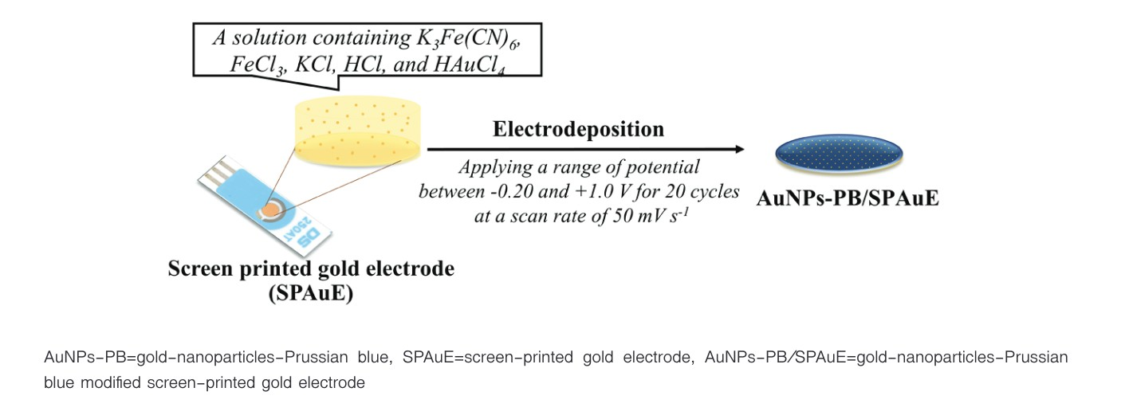
Figure 1 Schematic illustration showing the electrodeposition of the AuNPs-PB film on the SPAuE surface.

Results
Optimization study
The concentrations of K₃[Fe(CN)₆], FeCl₃ and the number of electrodeposited scan cycles were studied. After PB electrodeposition, the obtained cyclic voltammograms showed the redox peak currents of PB; as seen in Figure 2. At 0.25 mmol L⁻¹ K₃[Fe(CN)₆] and 0.25 mmol L⁻¹ FeCl₃, the current response was higher when increasing the number of scans. Cyclic voltammograms at the conditions of 0.50 mmol L⁻¹ and 1.0 mmol L⁻¹ of both K₃[Fe(CN)₆] and FeCl₃ showed similar PB signals, for which the maximum current response was found at 20 scans. At 10 scans, the current signal had the lowest response; whereas, it can be observed that a decrease in current response and wide displacement between the oxidation and reduction peak potentials occurred at 30 scans.

Surface morphologies
The surface morphologies of the PB film (Figure 2a) and the AuNPs-PB film (Figure 2b) modified on SPAuE were investigated using SEM. The PB film showed small sphere-like particles homogeneously dispersed on the SPAuE surface; whereas, the AuNPs-PB film was rough and exhibited many nanoparticles embedded within the PB film. Table 1 shows Values of Ipa, Ipc, and Ipc/Ipa ratio obtained from cyclic voltammograms of the PB/SPAuE and the AuNPs-PB/SPAuE.
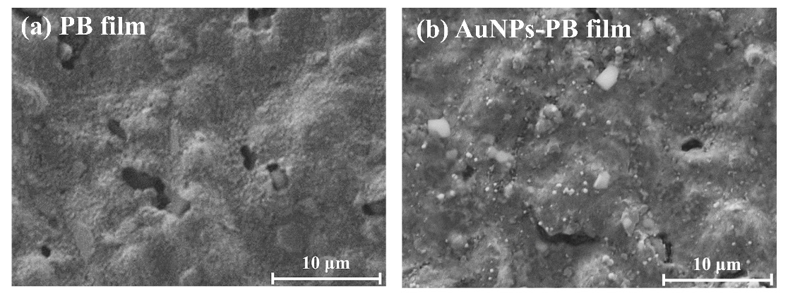
Figure 2 SEM images of the modified SPAuE: (a)PB/SPAuE, and (b)AuNPs-PB/SPAuE.

Table 1 Values of I_{pa}, I_{pc}, and I_{pc}/I_{pa} ratio obtained from cyclic voltammograms of the PB/SPAuE and the AuNPs-PB/SPAuE
Electrodes | I_{pa} (μA) | I_{pc} (μA) | I_{pc}/I_{pa} ratio
PB/SPAuE 1 | 110.17 | 72.96 | 0.66
AuNPs-PB/SPAuE 2 | 166.36 | 112.42 | 0.67

Discussion
In this study, it was demonstrated that the AuNPs-PB film deposited on SPAuE could contribute to the improvement of the electrochemical performance of the PB signal. Initially, the optimization study was carried out to determine the optimal conditions in the process of PB electrodeposition. As per the results showed, at 0.25 mmol L⁻¹ K₃[Fe(CN)₆] and 0.25 mmol L⁻¹ FeCl₃, the current response was higher when increasing the number of scans. This is due to the larger electroactive site of PB on the gold electrode surface. Moreover, it was noted that two reduction peaks were observed for every scan. Similarly, the couple reduction peaks at 0.50 mM K₃[Fe(CN)₆] and 0.50 mmol L⁻¹ FeCl₃ as well as 1.0 mM K₃[Fe(CN)₆] and 1.0 mmol L⁻¹ FeCl₃ were also found at 10 cycles. The electrochemical behavior, showing at a peak at approximately 0.15 V, is most likely massive precipitation of PB occurring in the process of the reduction of Fe³⁺ to Fe²⁺, as was discussed in Isfahani et al., 2019²². The mentioned mechanism is probably due to the reaction of the (Fe(III) [Fe(III)(CN)₆]) complex with the conductive material; as shown in reaction (2) and (3). However, the behavior for the concentrations of 0.50 and 1.0 mmol L⁻¹ at 20 and 30 scan cycles disappeared.

Conclusion
This study developed an AuNPs-PB modified SPAuE, using the electrodeposition technique. The optimal condition at a concentration of 0.50 mmol L⁻¹ K₃[Fe(CN)₆] and FeCl₃, and the number of scans at 20 cycles was applied to fabricate the AuNPs-PB film during the electrodeposition process. The performance of the AuNPs-PB/SPAuE was evaluated in comparison with a PB modified SPAuE without AuNPs. The AuNPs-PB/SPAuE offers great potential for the stability of PB-based electrochemical biosensors as an attractive alternative for use in medical biosensors.

Acknowledgment
We gratefully acknowledged the XXXX for the financial support. We would also like to thank xxxxxxxx for editing the English of the manuscript.
Funding sources
XXXXXXXX
Conflict of interest
There are no potential conflicts of interest to declare.
References
The example below is the corrected references of JHSMRs formatting
1. The Global Diabetes Community. Foot checks for diabetes [homepage on the Internet]. Coventry: Diabetes Digital Media Ltd; 2019 [cited 2020 May 7]. Available from: https://www. diabetes.co.uk/foot-care/foot-checks.html
2. Yang A, Yan F. Flexible electrochemical biosensors for health monitoring. ACS Appl Electron Mater 2021;3:53–67.
3. Waltzman SB, Shapiro WH. Cochlear implants in adults. In: Valente M, Hosfond-Dunn H, Roeser RJ, editors. Audiology treatment. 2nd ed. New York: Thieme; 2008;p.361-9.
4. Wu X, Cao M, Hu C, He X. Sonochemical synthesis of Prussian blue nanocubes from a single-source precursor. Cryst Growth Des 2006;6:26–8.
5. Zhang M, Hou C, Halder A, Ulstrup J, Chi Q. Interlocked graphene–Prussian blue hybrid composites enable multifunctional electrochemical applications. Biosens Bioelectron 2017;89:570–7.
6. Keihan AH, Ramezani Karimi R, Sajjadi S. Wide dynamic range and ultrasensitive detection of hydrogen peroxide based on beneficial role of gold nanoparticles on the electrochemical properties of prussian blue. J Electroanal Chem 2020;862:114001.
7. Karyakin AA. Prussian blue and its analogues: electrochemistry and analytical applications. Electroanalysis 2001;13:831–5.

